Your Name here

MMA Companion
Computer Science NEA

Contents
Developmental Testing Error! Bookmark not defined.
Testing Error! Bookmark not defined.

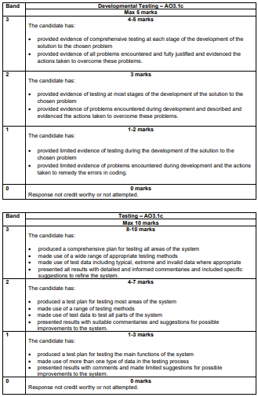

This is for your reference only and needs to be deleted when it is handed in as a final copy.

Please also delete any of my comments from the sections below, on final hand in

Stage | Problem/Result | Evidence | Action | Evidence of action
The leaderboard will display the fighter's name, rank number, record, win/loss streak, weight class and methods of winning (number of subs/decisions/kos). (Whenever I refer to displaying the table, this is the general process.)
Proto | I did not set my parameters in the code correctly (2.1 and 2.2) I put the string “None” instead of Nonee | 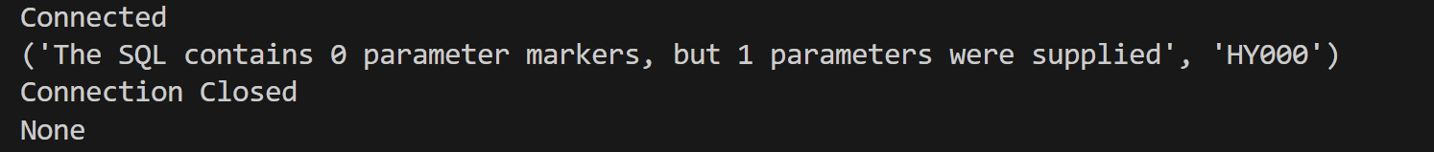 | Set params to equal None instead of “None”
Proto | Table is outputted as an array (2.1 and 2.2) |  | No action needed
Proto | Table with specific required fields is outputted (2.1 and 2.2) |  | No action needed
Proto | Leaderboard table didn’t load because I had the login button set to navigate not load the table (2.3 and 2.4) | 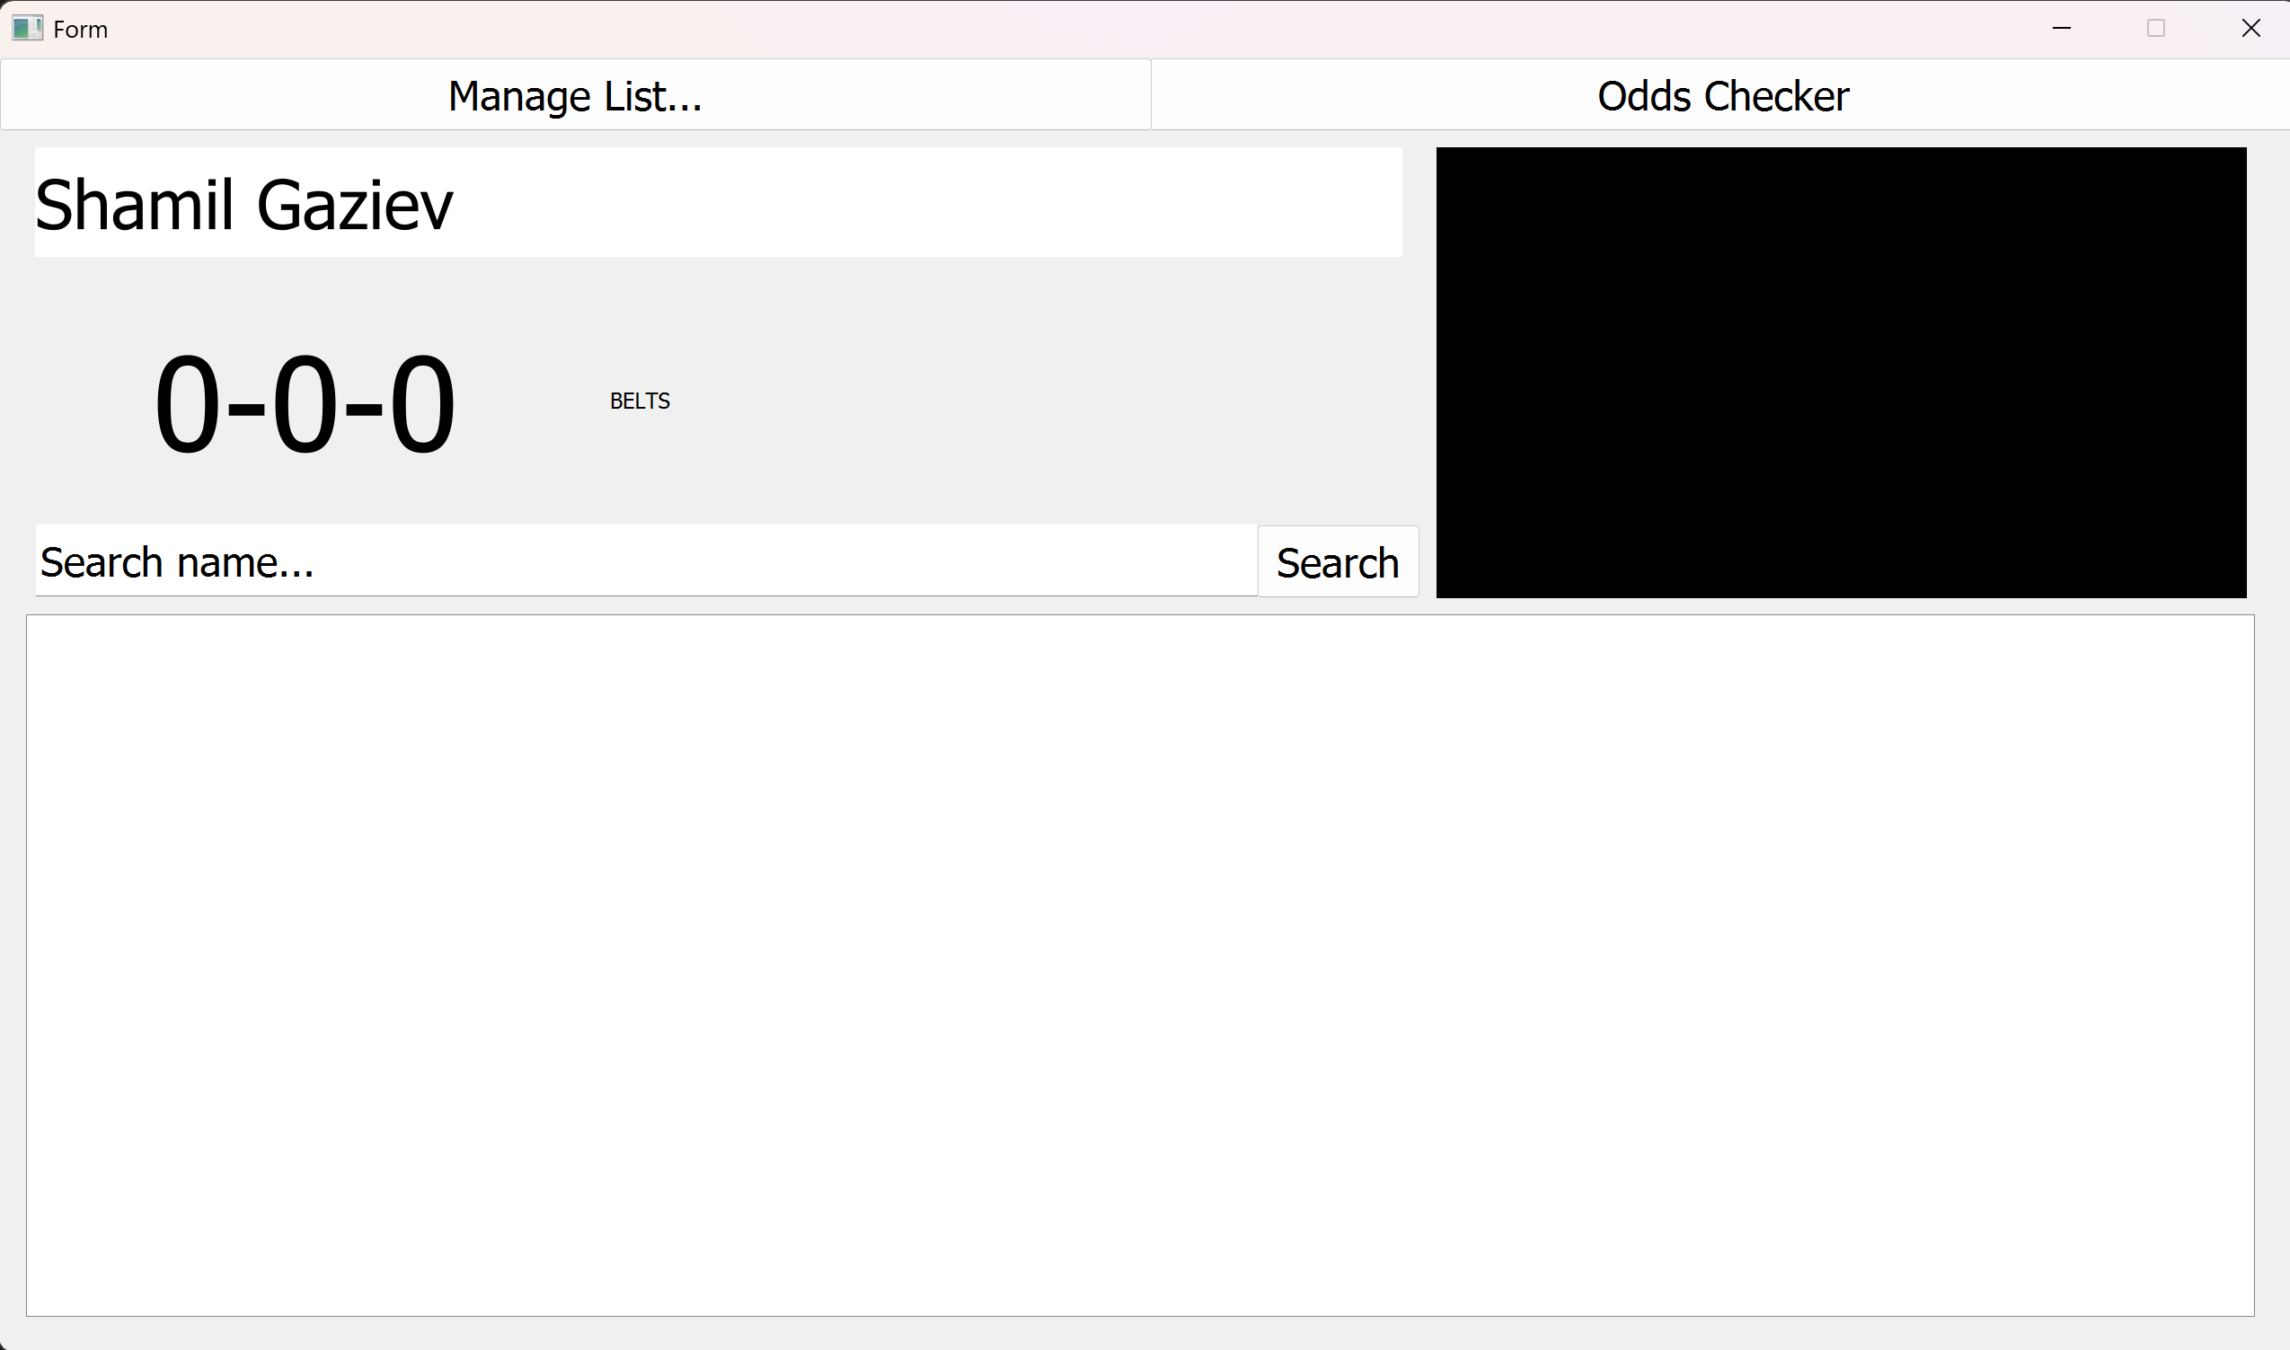  Leaderboard did not load | Set login subroutine to load leaderboard instead of navigate (load leaderboard will navigate) | 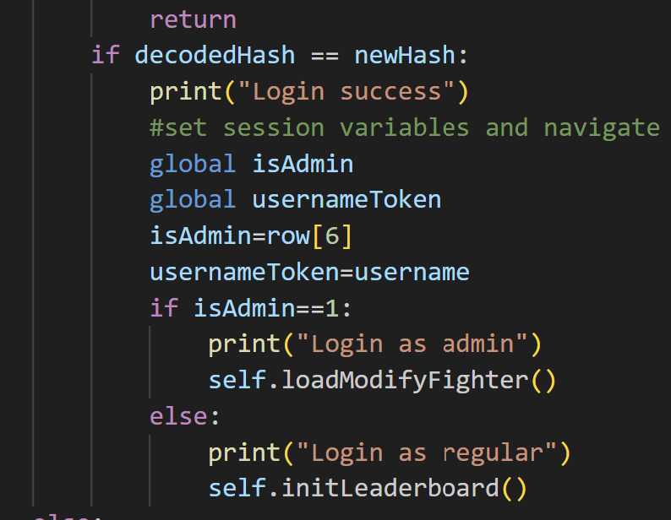
Proto | Table cleared and set to a model (2.3 and 2.4) | 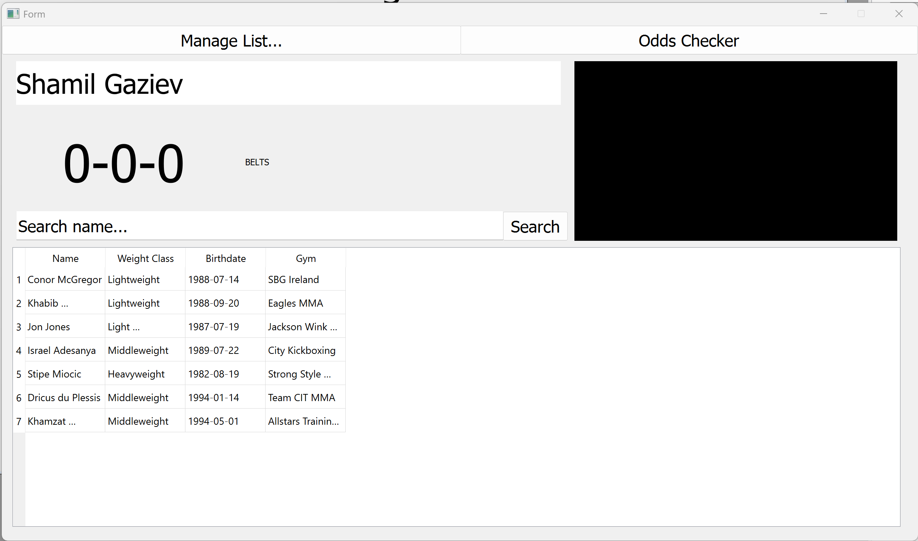 | No action needed in terms of the actual subproblem
Proto | Table isn’t sized properly to the tableView |  | Changed the header and table properties to make it look nicer | 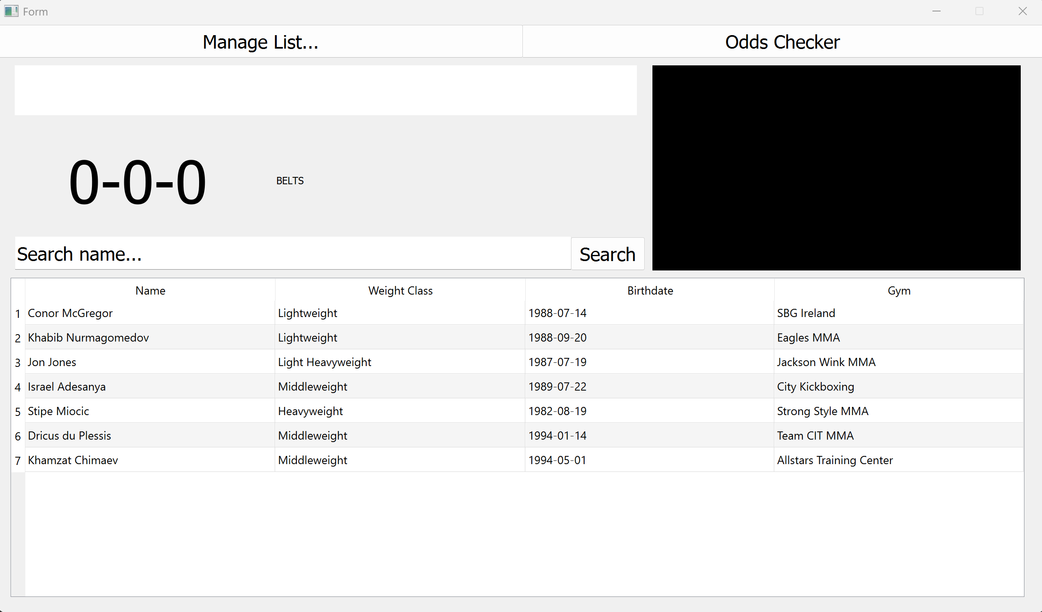
Proto | I kept self when loading the default image |  | Took self out
Proto | I referred to the element when loading the image through itself | 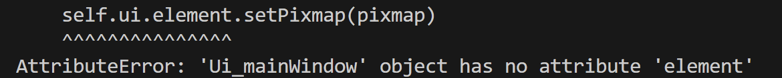  (I meant self.ui.element but it would come out as self.ui.self.ui.element) | Did element instead of self.ui.element | 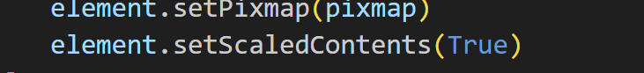
Proto | Nothing happens when I click the table cells because I messed up the handler | 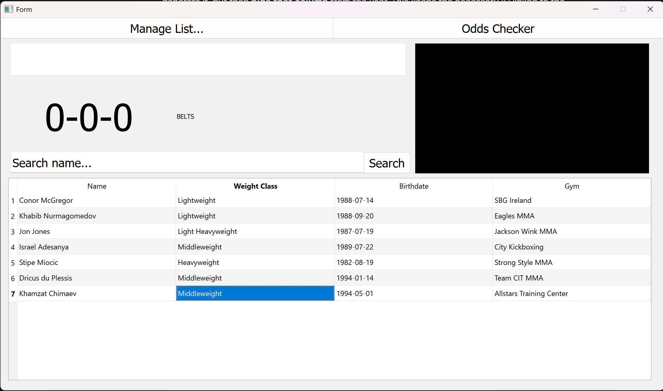 | Corrected handler
Proto | Images look stupidly scaled because the pixmap properties don’t preserve the aspect ratio | 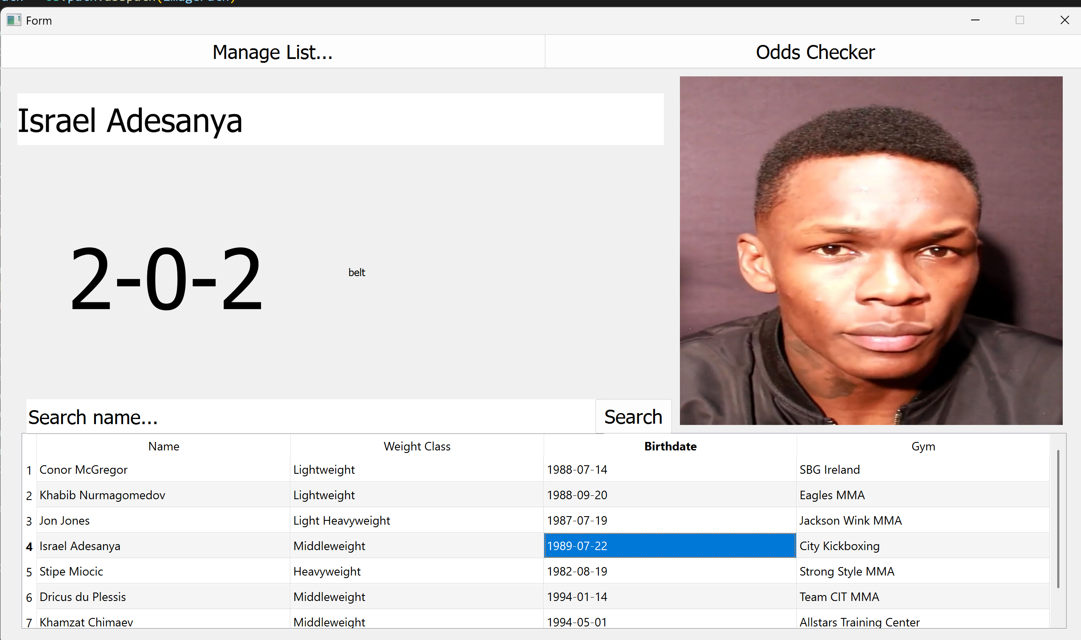 | Set new pixmap properties when loading images to preserve the aspect ratio | 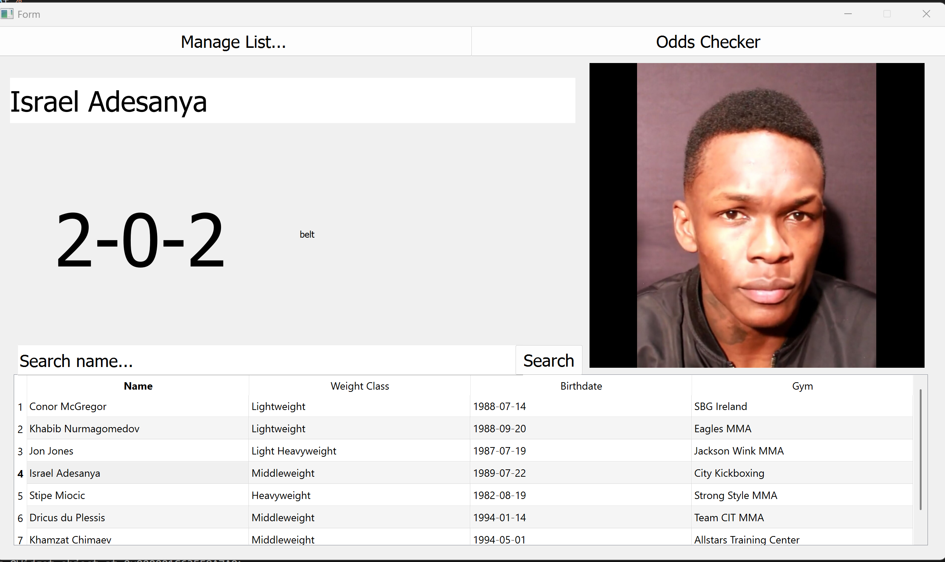
Proto | PyQT cannot get the text out of the search bar because it’s the wrong element | 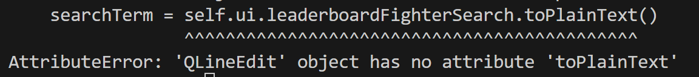 | Change leaderboardfightersearch to a TextEdit element
Proto | Result of search also models the id inadvertently | 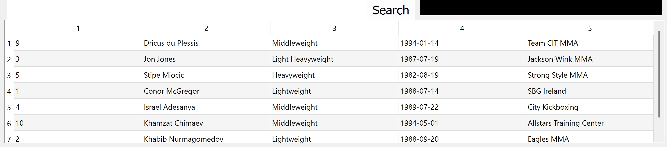 | Add header declarations into the modelling of the search table | 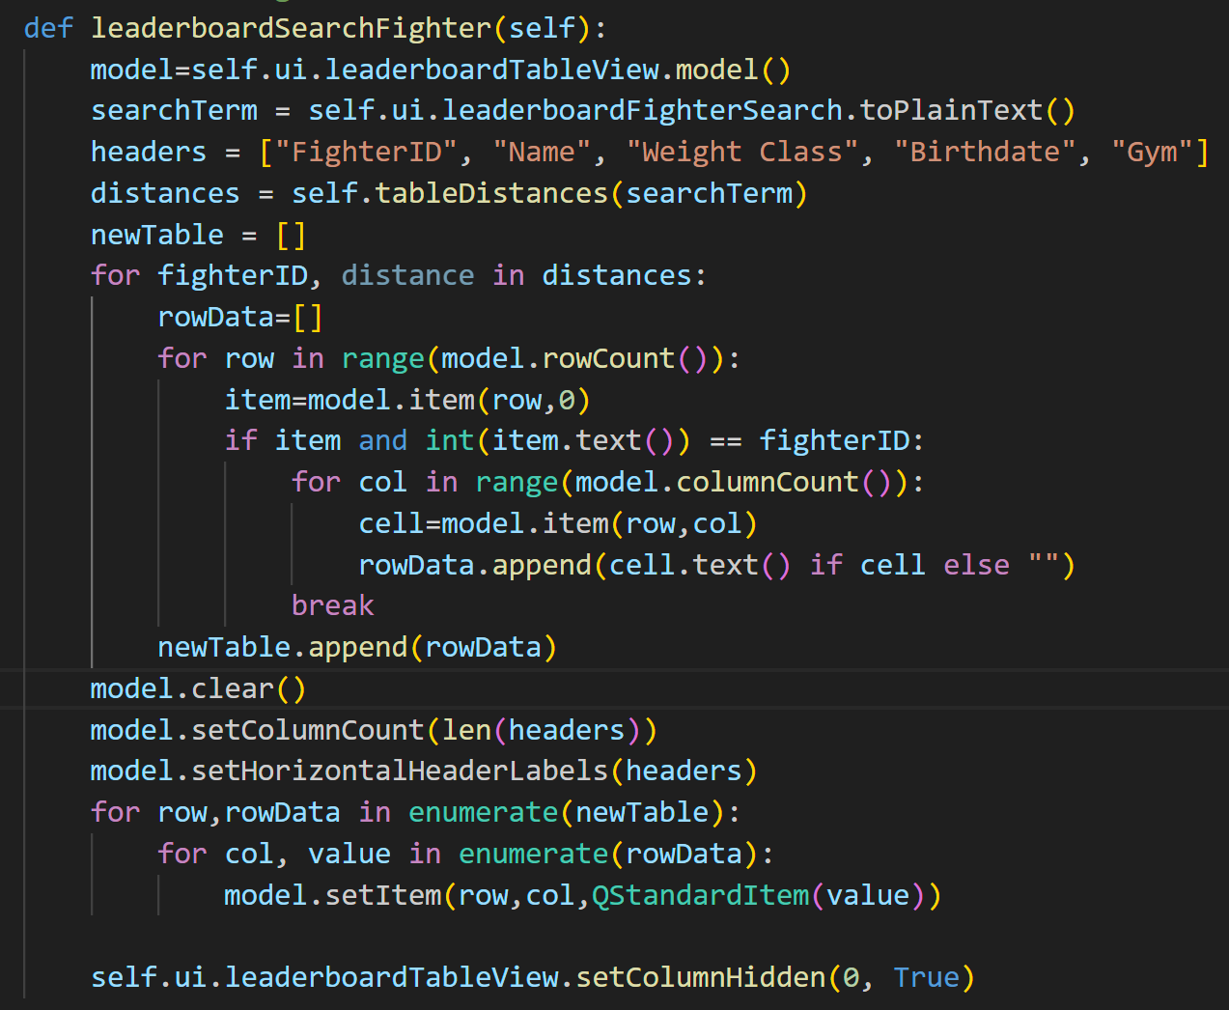
Proto | Double click to profile mechanic stutters because of image loading times | 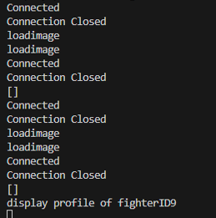  Is hard to show without showing it in real time, but you can see how it is tedious to load and double-click at the same time | I need to thread the request so everything doesn’t stop to load the image
Proto | Implementing tooltip system onto edit fighter fights list so admins can see the opponents of each fight | 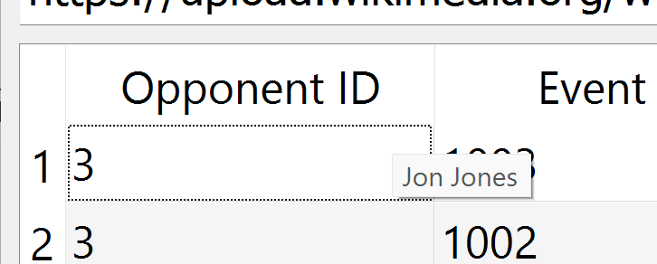 | No further action needed
Proto | When the fighter profile is switched it doesn’t clear the image | 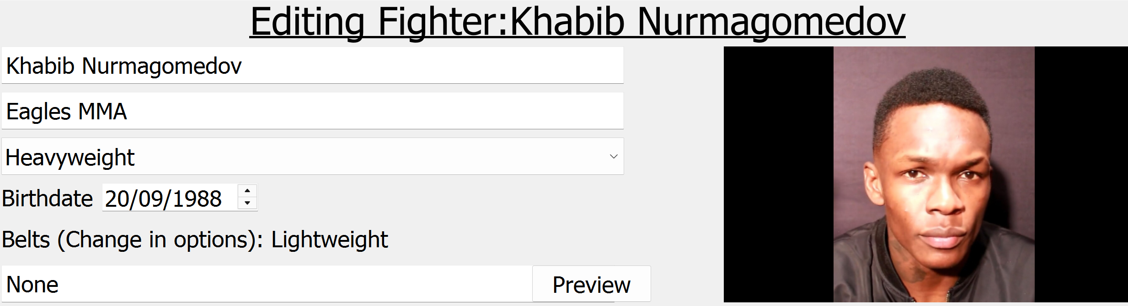 | Clear the element at the beginning of the load image subroutine | 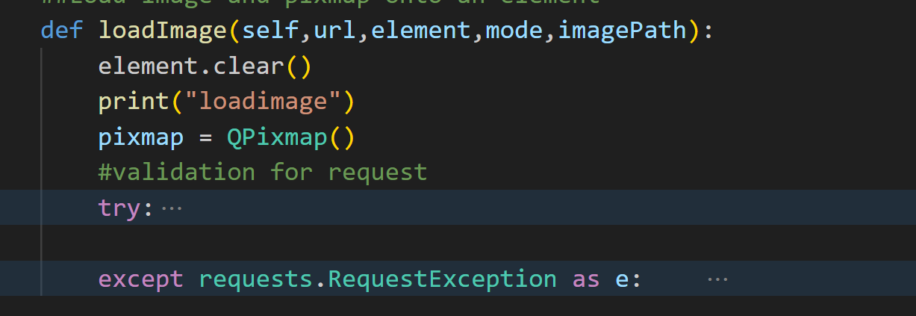
Proto | Implement table editing system | 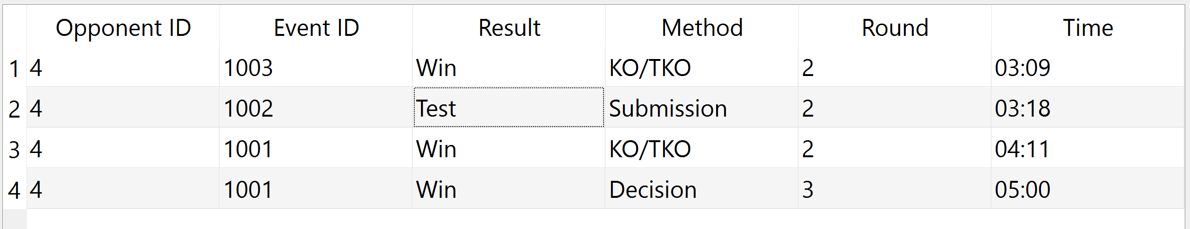  When I clicked submit and came back to the table it hadn’t updated
Proto | Double click passes to subroutine with fighter ID |  | No further action needed
Proto | Pie chart looks ugly because of the jargon of the unused things | 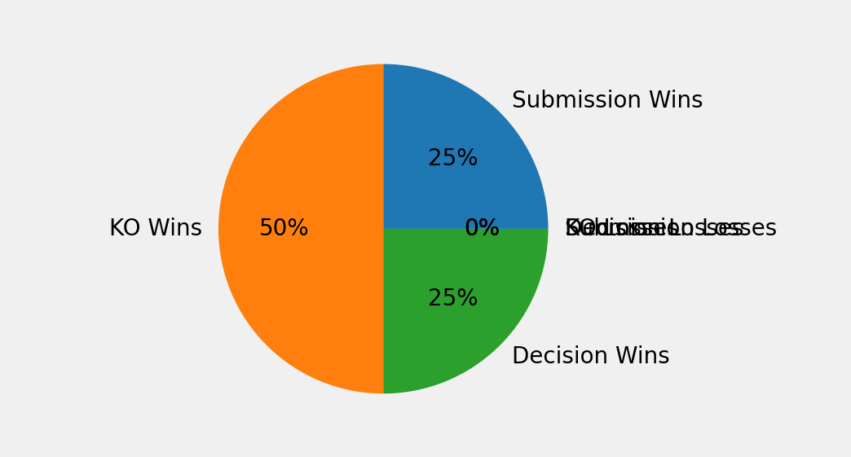 | Omit the parts of the pie chart that aren’t used | 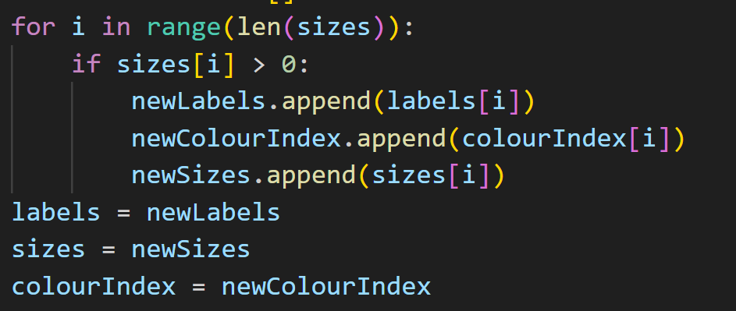  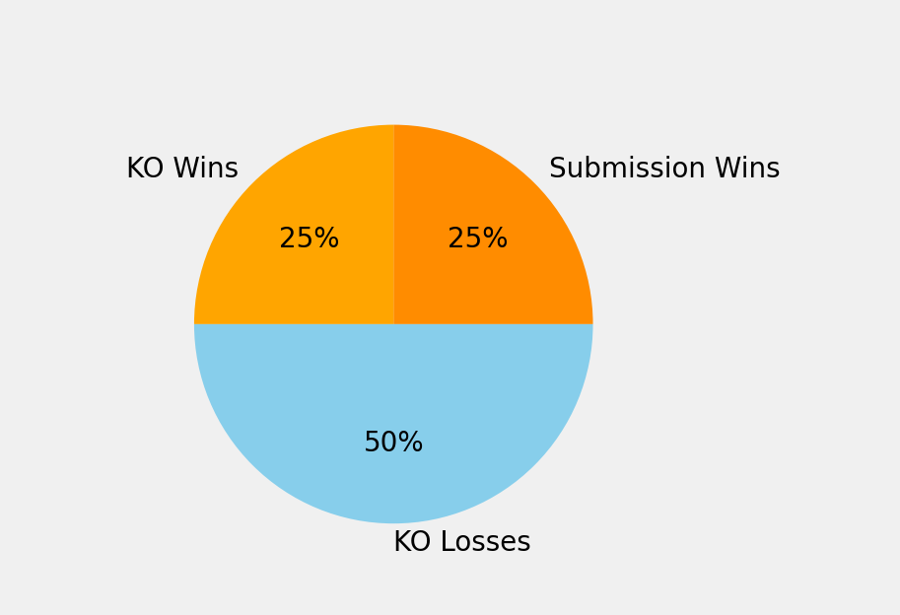
Proto | I messed up the parameters in this query | 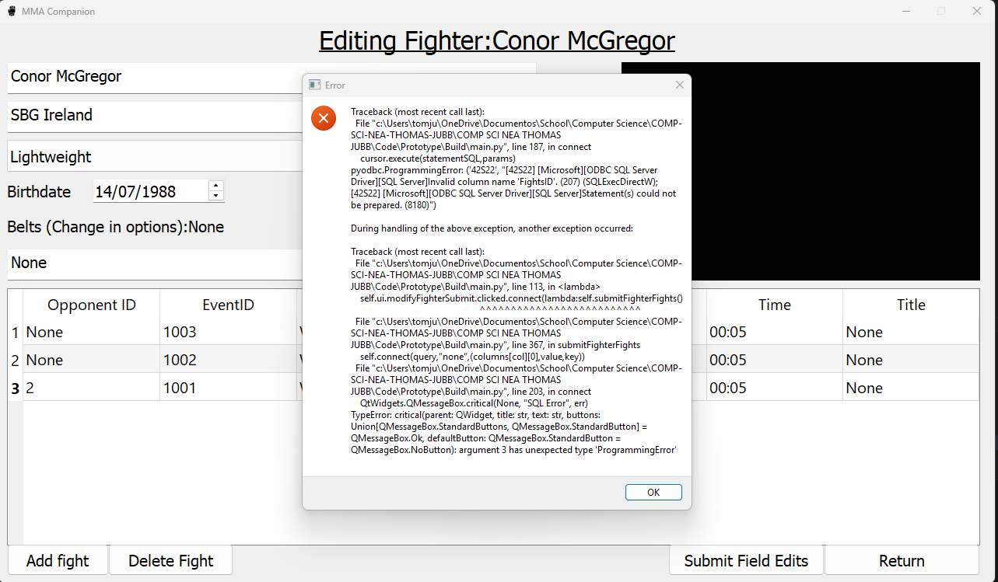  (Image says it expected 1 parameter but two was supplied | Take out parameter | Runs fine now
Proto
Proto
Proto
Proto
Proto

